In 2020, the College of Engineering at the University of Arkansas developed a committee to begin data collection and assessment of our progress toward creating a just, equitable, and inclusive environment for our students, staff, and faculty. The result of this committee was 1) an assessment of our internal policies related justice, equity, diversity, and inclusion (JEDI), 2) an assessment of how other colleges of engineering across the United States were addressing issues of JEDI, and 3) conducting interviews with students, staff, and faculty historically marginalized students within the college about their sense of inclusiveness and changes they would like to see implemented within our college.

From this initial assessment and evaluation, we begun the process of addressing issues of JEDI within our college. First, we hired Patrice Storey, the inaugural Assistant Director of JEDI to develop and implement a JEDI plan for our college. Mrs. Storey and the College of Engineering then developed our JEDI mission and vision statement (see JEDI Plan, p. 1). We also developed definitions for JEDI informed by prior research and larger efforts across numerous initiatives (see JEDI p. 1-2). Finally, we developed a set of goals and initiatives for the College of Engineering for the next 5 years. Our plan is highlighted below.

JEDI Mission
It is time that we as engineers, computer, and data scientists rethink our role in society and how we contribute and combat larger injustices. Indeed, to develop competent members of the engineering community, this will require more than just technical skills.¹ As engineers we do not develop or use technologies that are separate from the cultural and implicit biases that surround us—nor do we develop technologies free from our own implicit biases.¹ Thus, we must be able to understand and address the complex social injustices and challenges that face our society and influence the problems we solve.

To address these issues, the University of Arkansas’s College of Engineering is committed to developing and fostering an environment which emulates our core values of Justice, Equity, Diversity, and Inclusion (JEDI). We believe that diversity and inclusion among our students, staff, and faculty creates a thriving academic environment where varying perspectives are valued and respected. We believe that justice and equity are needed to dismantle the systemic injustices that reproduce disparities in who and what type of engineering education and experience some have.

Given that JEDI approaches are focused on addressing how individual, relational, community, and societal barriers contribute to discrimination and oppression, we are emulating this approach and creating JEDI initiatives that address these different systematic barriers within engineering. Review our JEDI plan. We hope that in the coming years, the results of the JEDI plan have members of our community engaging in courageous and honest conversations about the systematic barriers which prevent some, but not all, from achieving their full potential and what each of us can do to address these barriers.²

¹Gallimore, 2021
²Wilson-Kennedy et al., 2020

JEDI Vision
By developing and implementing a holistic JEDI approach, we aim to create a community of belongingness and lifelong learners who engage in identifying, challenging, and redressing power imbalances within engineering. We want our impact to extend beyond classrooms, research, as well as the campus community to create larger cultural changes within the field and society.

Defining JEDI

Justice: Dismantling institutional and structural barriers to resources and opportunities in society, especially in engineering, so that individuals and communities can live a dignified and full life. Within justice, we acknowledge that different systems of power and privilege have existed for years, and our responsibility as educators and leaders is to address the context of systematic oppression in our teachings, research activities, and daily interactions.

Equity: A guarantee of fair treatment, access, opportunity, and advancement for all individuals while also identifying and eliminating barriers that prevent full participation of different groups. Within equity, we acknowledge that society has historically underserved and underrepresented certain groups. Thus, a system which addresses these historical imbalances is needed to assist with achieving equity.

Diversity: Diversity can mean different things to different individuals. We define diversity as differences between us that determine which barriers and advantages we encounter in our lived experiences. Diversity can include, but is not limited to the following elements of a person:
- Gender Identity  - Racial Identity  - Ethnicity  - National Origin  - Native Language  - Religion/spiritual beliefs  - Socioeconomic Status | - Sexual Orientation  - Veteran Status  - Neurodivergent  - Disability  - Age  - Documentation Status  - Differing ideas/perspectives  - Cultural Background
Inclusion: The act of establishing and fostering environments where diverse individuals or groups can and feel welcomed, respected, supported, and valued in bringing their full, authentic selves to school or work. Within inclusion, we aim to develop a welcoming climate that embraces each person’s unique perspective, embodies feelings of belonginess, and offers respects in the words and actions of those around us.

JEDI definitions are informed from the following sources: US Climate Network, Public Lands Alliance, The Arvana Group, MBARI, and D5 Coalition,

Land Acknowledgement Borrowed from Fulbright College
The Indigenous history of the land that the University of Arkansas campus sits on goes back to time immemorial. Across that expanse of time, many successive groups have lived here and created sacred legacies in this area. The College of Engineering acknowledges that Indigenous individuals were forced to leave their ancestral lands, including the Osage, Caddo and Quapaw Nations with ties to northwest Arkansas. We further recognize that a portion of the Trail of Tears runs through our campus, and that the Cherokee, Choctaw, Muscogee (Creek), Chickasaw and Seminole Nations passed through what is now Arkansas during this forced removal. We acknowledge all Indigenous teachers, researchers, students, and all other residents in our community and region today.

Legend and Keywords:
Historically Marginalized (HM): represents groups that were denied full participation in society and can include many communities such as people of color, women, LGBTQI+, the disabled, seniors, people whose first language is not English, immigrants, and many more.³

College of Engineering (COE)

Justice, Equity, Diversity, and Inclusion (JEDI) Office

³Oregon Heritage

JEDI Goals

Goal: To develop and reinforce a climate of belongingness and celebration where faculty can bring their authentic selves to work and feel respected in their identities and perspectives.

Target Area: Recruit Diverse Faculty

The COE aims to expand and make meaningful steps to create a college climate that is more reflective of the students it serves. To do this, the COE will identify several different policies at the college and institutional level that may unintentionally prevent the COE from hiring faculty from HM identities. Additionally, the COE will adjust parameters for first round interviews and on-campus visits to ensure more faculty from HM identities are brought to campus for interviews. The COE will also encourage faculty of diverse backgrounds to apply; this will be complimented by individual and college level recruitment of diverse faculty. The end goal is to begin hiring cohorts of faculty of different HM identities.

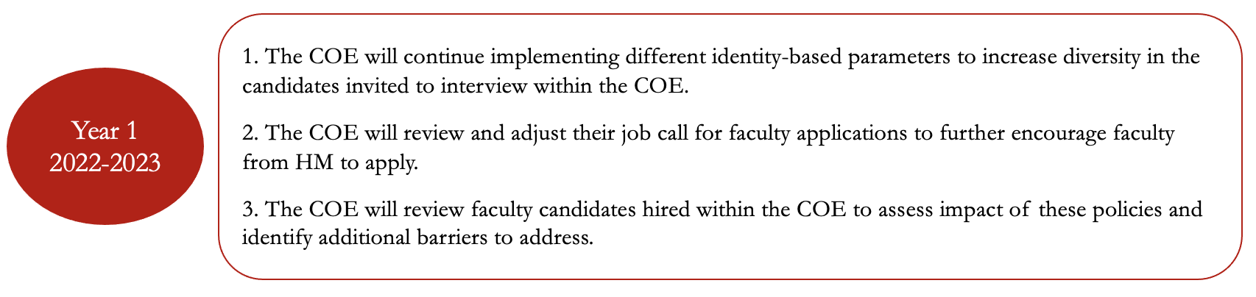

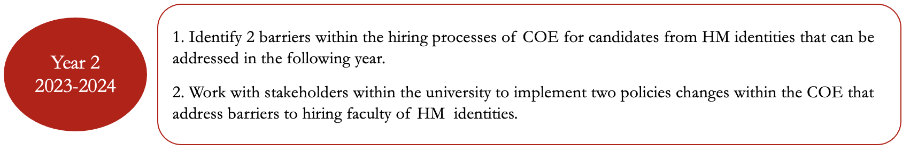

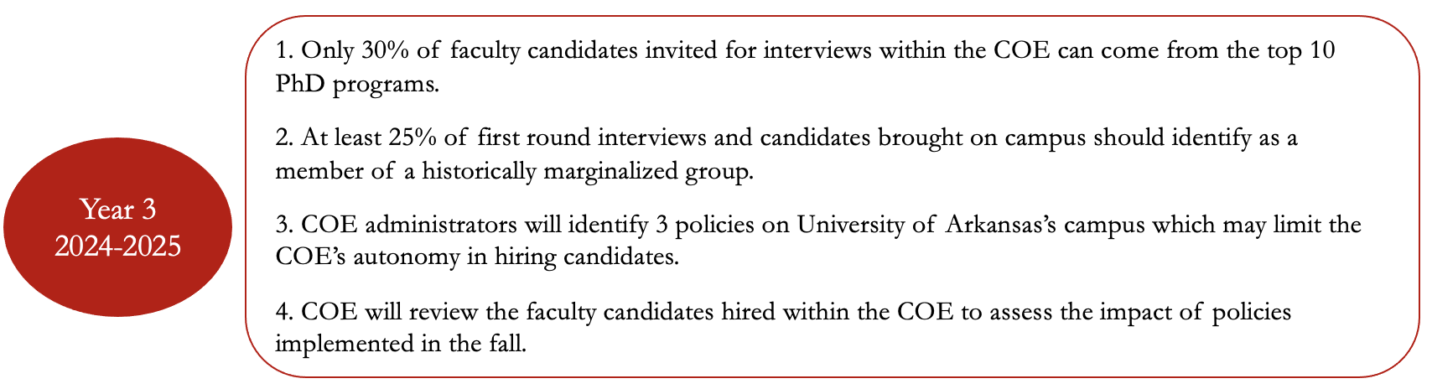

Target Area: Recruit Diverse Faculty

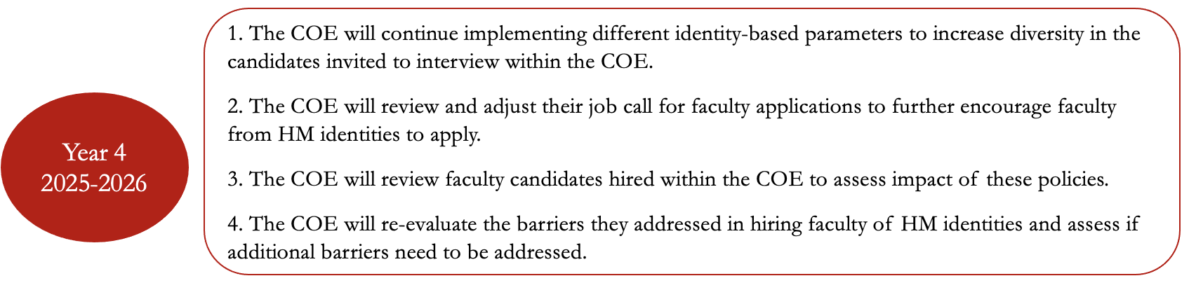
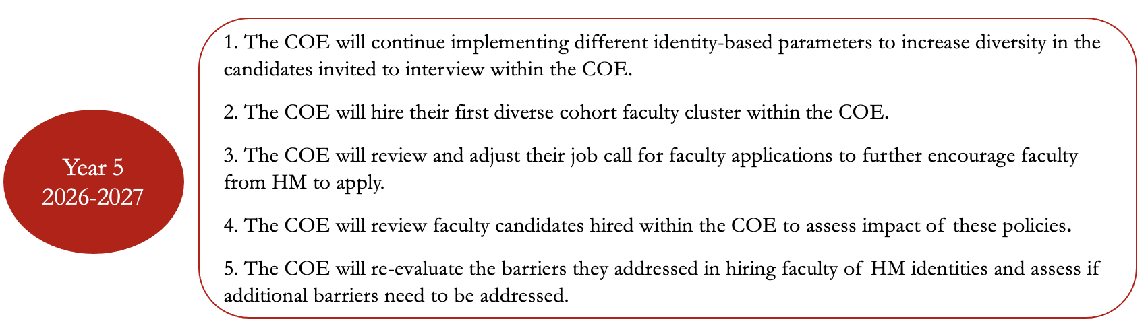

Target Area: Retain and Support Diverse Faculty within the COE

The COE aims to create initiatives that assist faculty from HM identities build stronger networks and sense of community within the college. These initiatives are focused on creating spaces where faculty of HM identities can network with others on research, teaching, and general concerns and successes they have within the college. The COE will host several lunches and implement a new mentoring program for junior faculty of HM identities. Additionally, given that traditional teaching evaluations tend to be biases against faculty from HM identities, the COE will implement a new metric for teaching evaluations to address these biases. The COE will assess people’s experiences with each of these new initiatives to assess their impact, solicit feedback, and improve the initiatives over the course of 5 years.

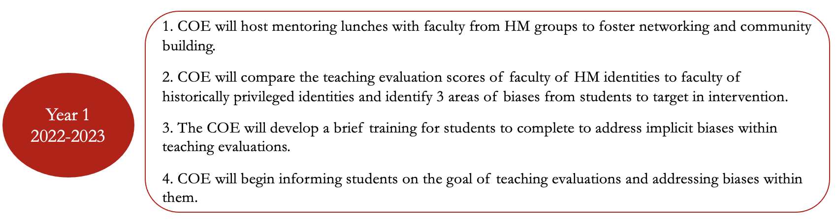

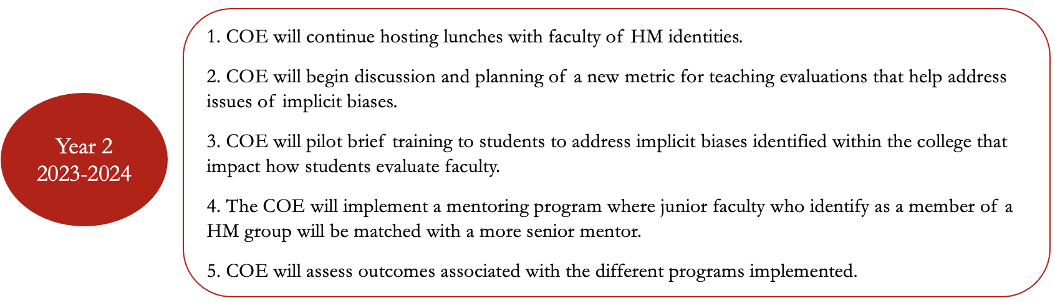

Target Area: Retain and Support Diverse Faculty within the COE

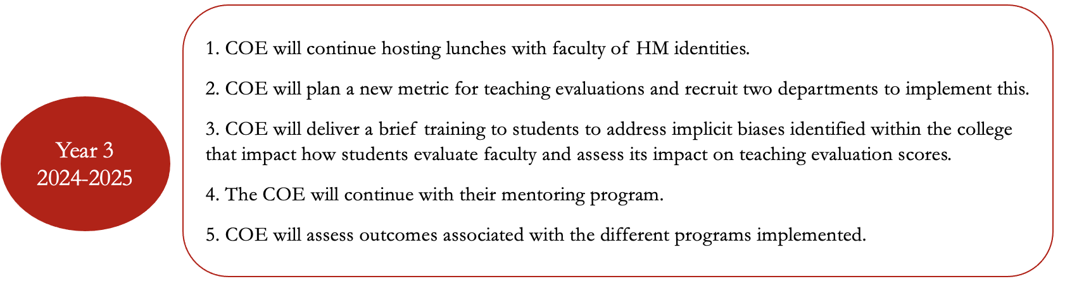

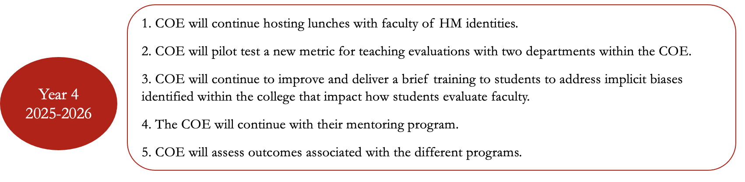
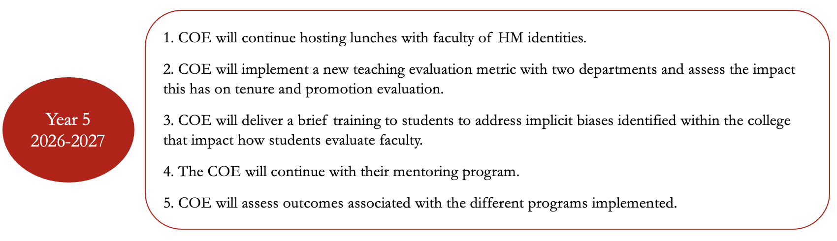

Target Area: Build Value and Commitment to JEDI

The COE intends to create a culture within the college that values and embraces principles of justice, equity, diversity, and inclusion (JEDI). To do this, the COE will host numerous trainings each year related to different aspects of JEDI and host semester readings with faculty focused on JEDI principles. The JEDI office within the COE will seek to honor and award faculty who embrace principles of JEDI through various awards. Additionally, the COE and JEDI office will work to training faculty on equitable mentoring practices. Finally, the JEDI office will assess the impact of these initiatives on faculty’s understanding of JEDI.

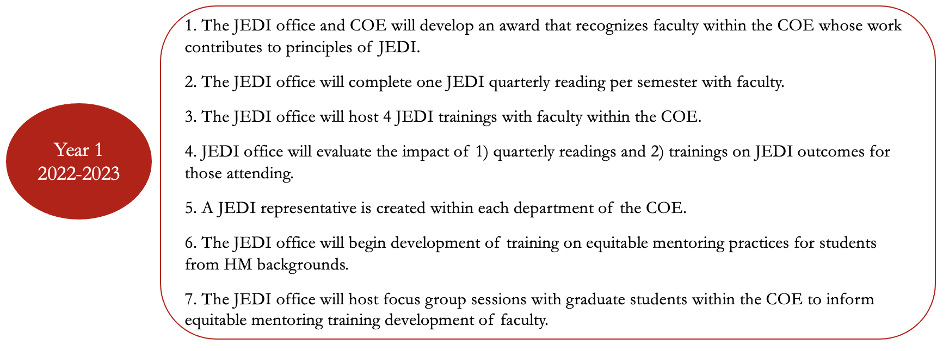

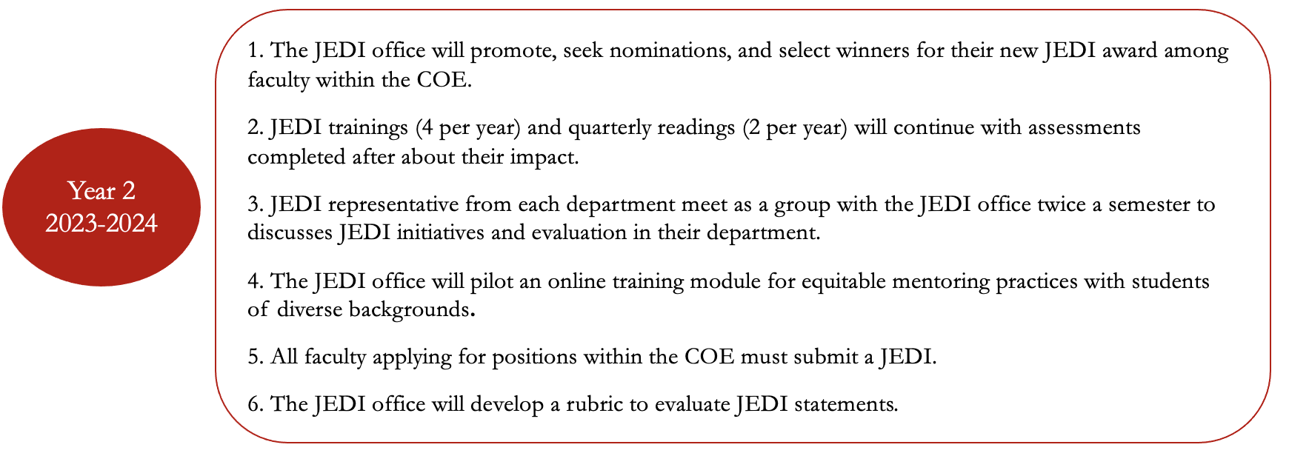

Target Area: Build Value and Commitment to JEDI

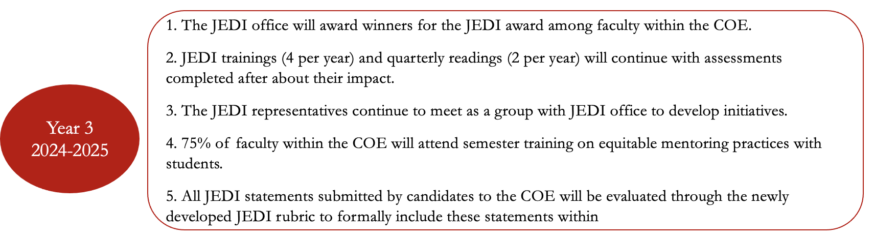

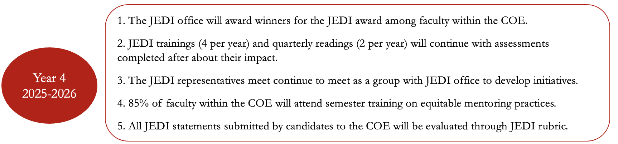

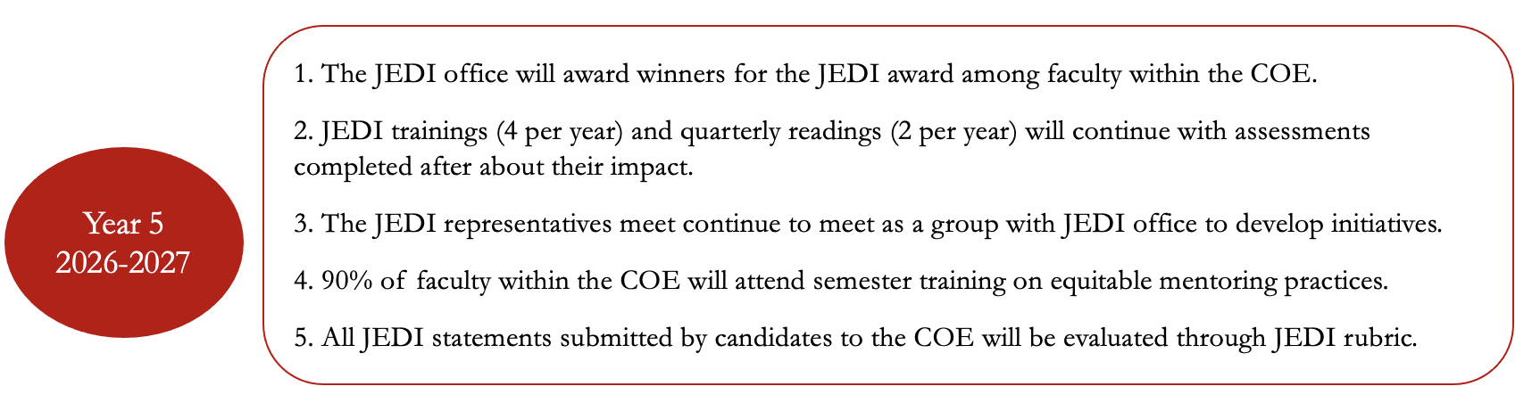

Target Area: Assess the Global Impact of JEDI Initiatives on the Climate within the COE

The COE aims to design and implement a climate survey among faculty and staff that will be administered every year for 5 years to assess the larger impact of their initiatives within the college. Further, these climate surveys will be used to inform different barriers to creating a climate of belonginess and provide the COE with areas to address.

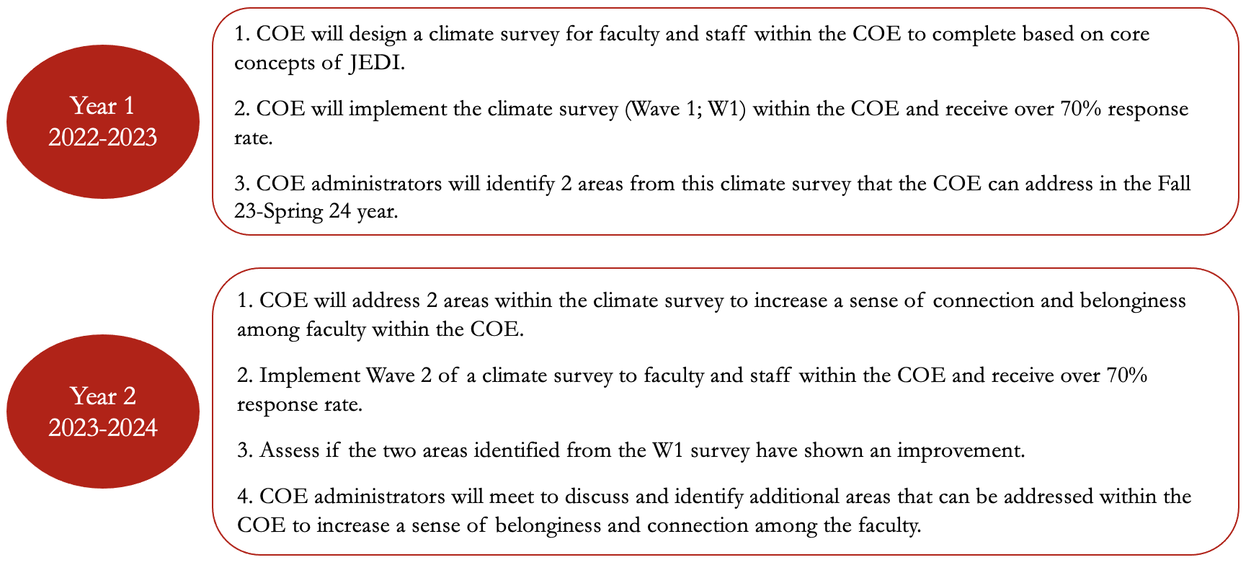
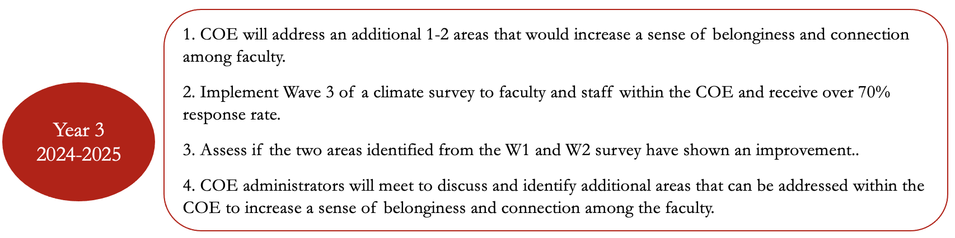

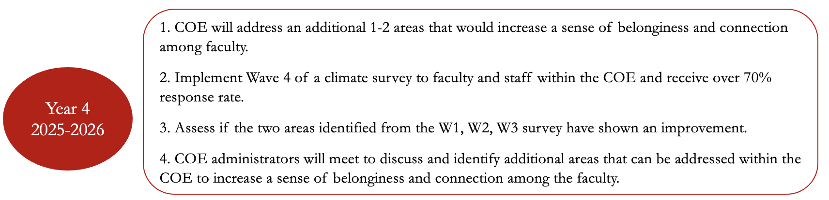

Target Area: Assess the Global Impact of JEDI Initiatives on the Climate within the COE

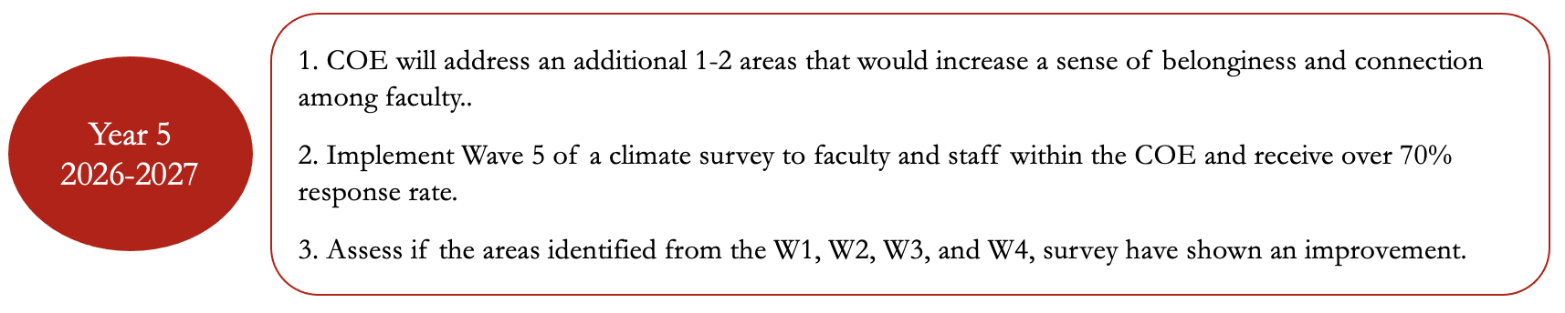

Goal: To build a community where students of various backgrounds and perspectives feel connected and represented in the COE.

Target Area: Recruit Diverse Students to the COE

The COE is committed to further diversifying who has access to an engineering education and taking meaningful steps to adjust our recruitment process to bring in a new generation of engineers. This process begins with youth involved with the K-12 system, college students at community colleges, and college students at identity-based schools or involved with identity-based organizations. Thus, the COE and JEDI office will be hosting open houses (virtual and in-person) about the COE with different groups (e.g., high schools, HBCUs) to extend their reach. Those who attend these open houses will be given discounts on their application fees to the COE. The COE also offers numerous summer camps related to engineering and will provide additional discounts to students who return each summer and progress through these camps.

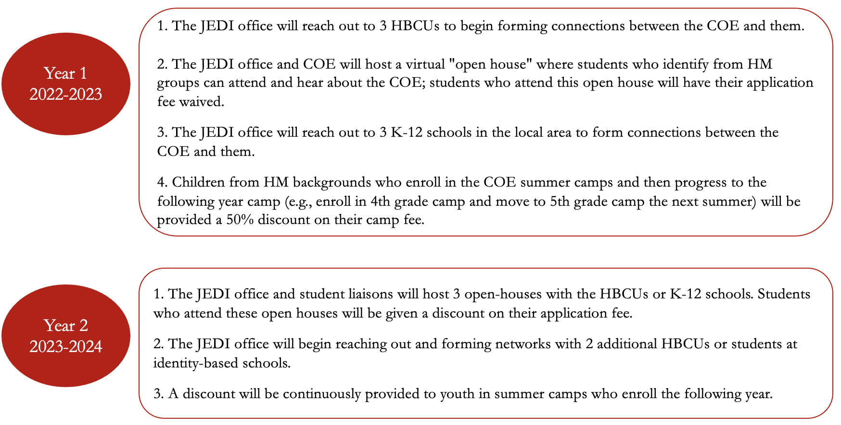

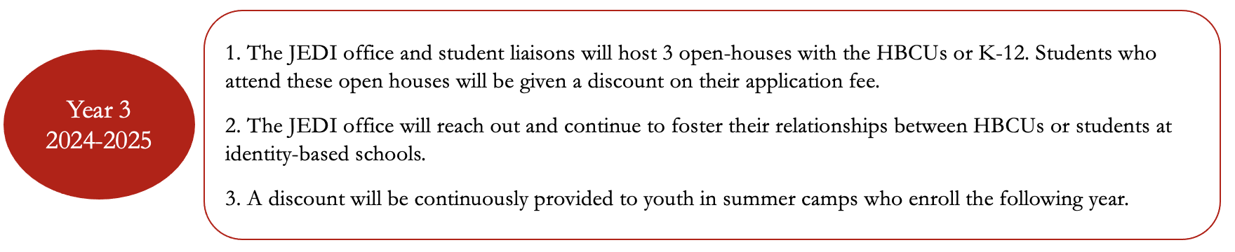

Target Area: Recruit Diverse Students to the COE

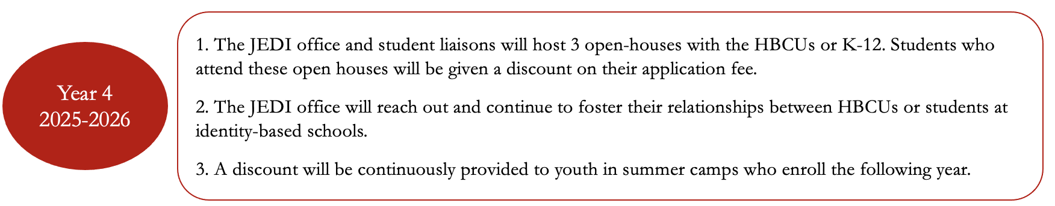

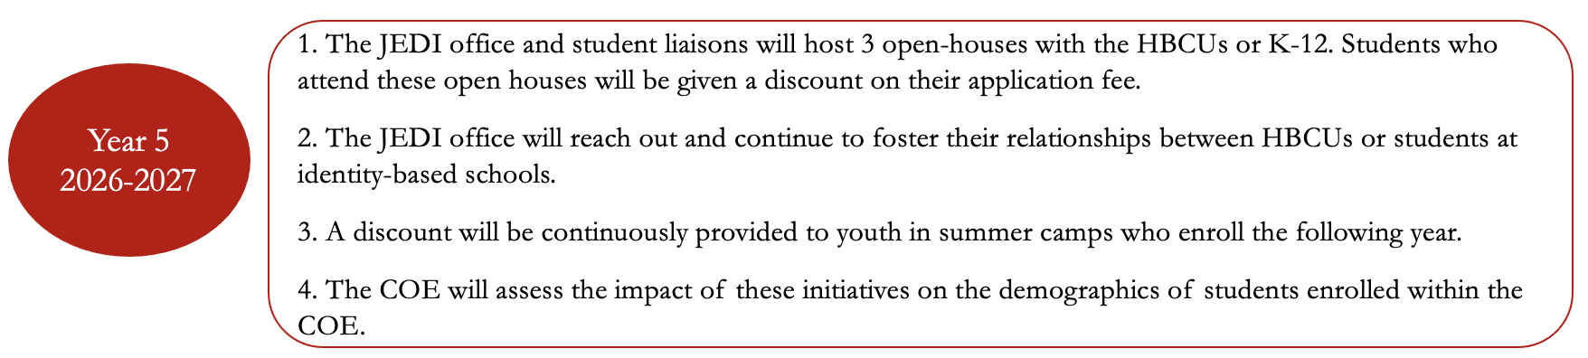

Target Area: Recruit Retain and Support Students from Historically Marginalized (HM) Identities

The COE wants to ensure that students from various backgrounds who join our community feel supported and finish their college career. As such, the COE will implement and evaluate a climate survey each year to assess students’ sense of belonginess within the COE. We will also host lunches, networking events and develop new scholarships for students from HM identities. The COE will also create a student liaison committee to the JEDI office who will provide feedback on initiatives and assist with developing new ones within the college. Finally, to recognize students who do excellent work within JEDI, we will develop a new award to recognize these students. The COE will assess the impact of these efforts on retention and perceptions of support for students within the COE.
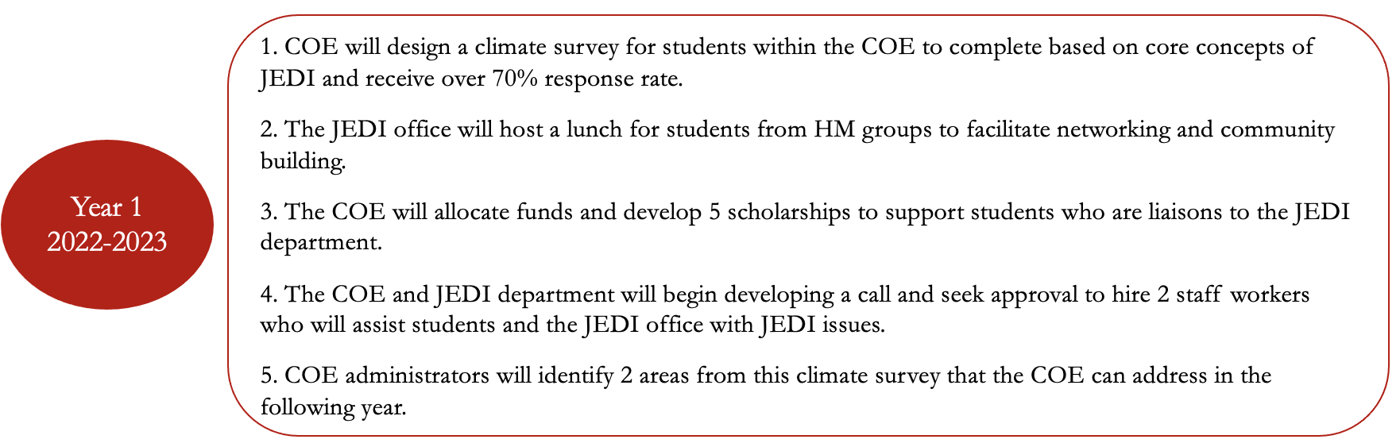

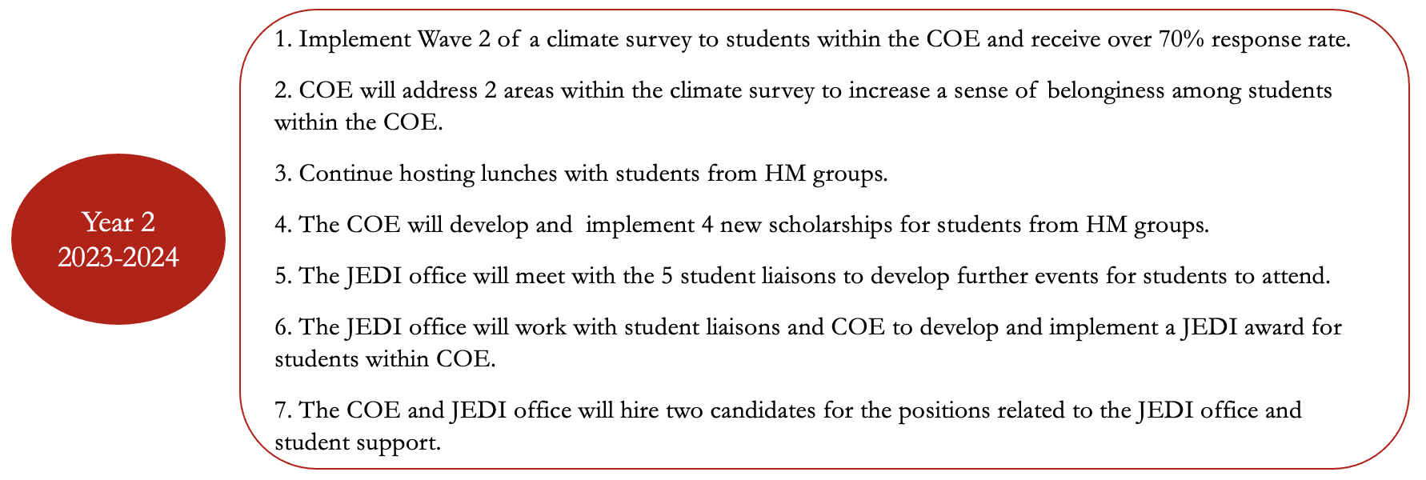

Target Area: Recruit Retain and Support Students from Historically Marginalized (HM) Identities

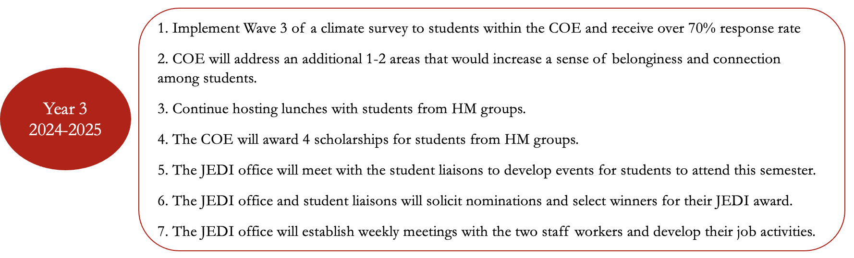

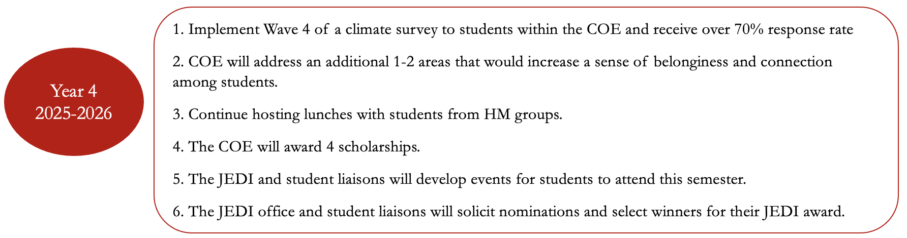

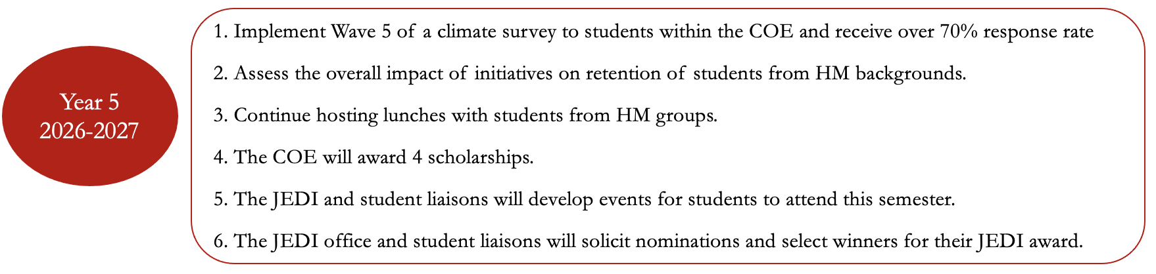

Target Area: Support Students of HM Identities in their Engineering Studies

Within engineering, there is a need to support students from HM identities broadly, but also within their engineering studies. Thus, we are implementing identity-based study halls and tutors to provide students of HM identities support systems within their community. Students who tutor within these study halls will be paid for their time and those who attend them will be encouraged to apply to be tutors after they finish. We will also implement a mentor-mentee program with students of HM identities where they are matched with a faculty mentor for 1 year to increase their involvement in research and the COE. The JEDI office will assess the impact of these study halls and mentor-mentee matches on students’ grades and engineering experiences within the COE.

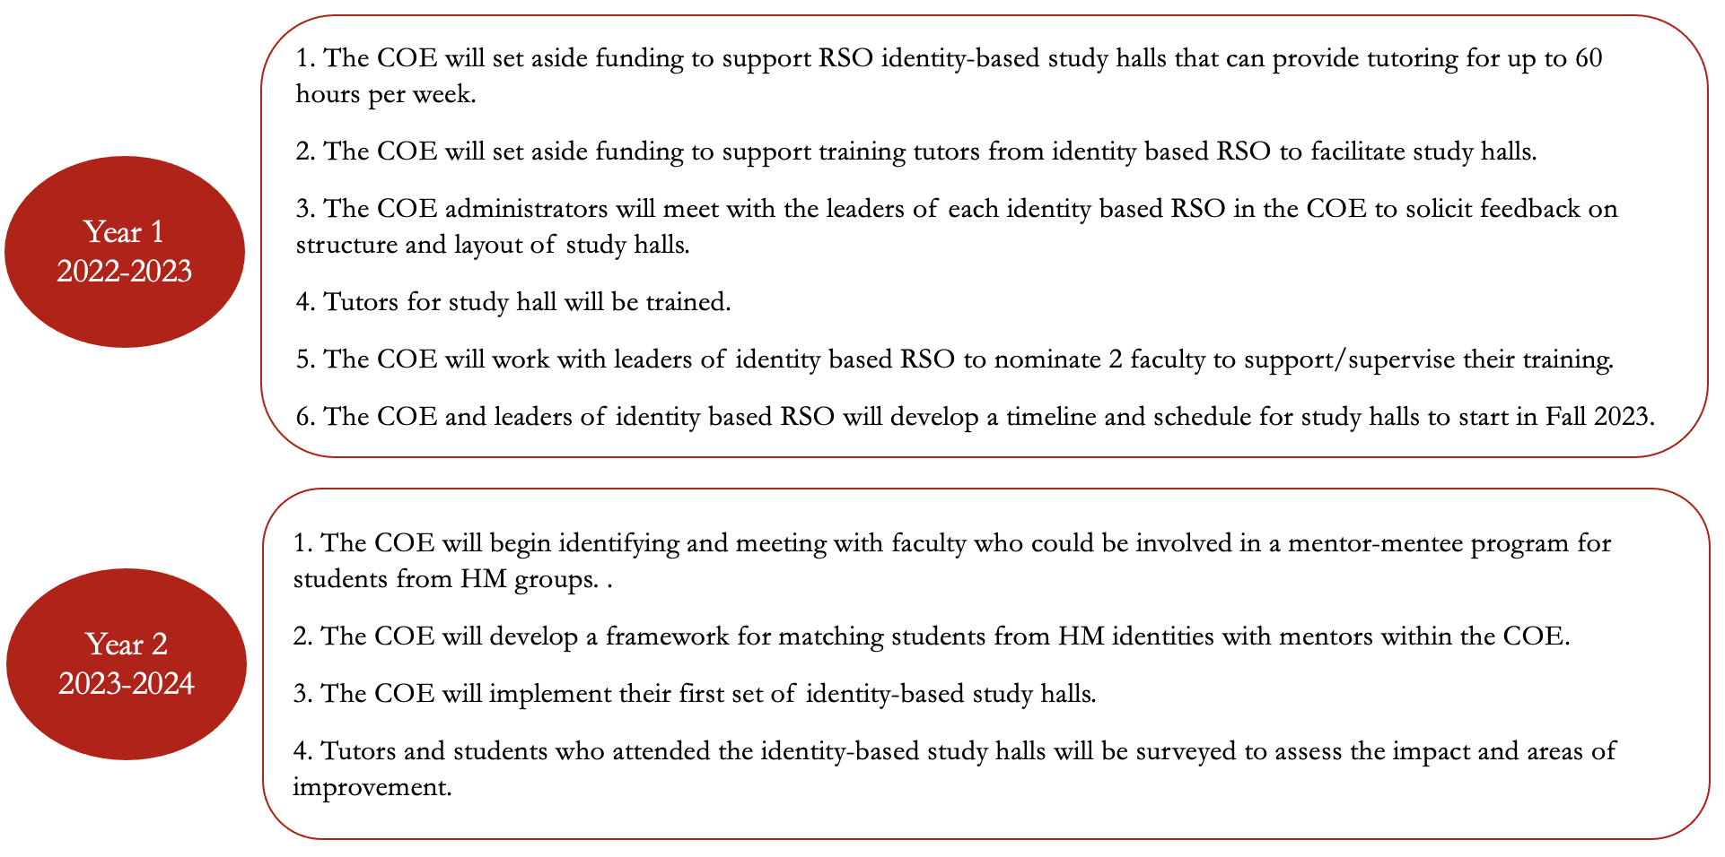
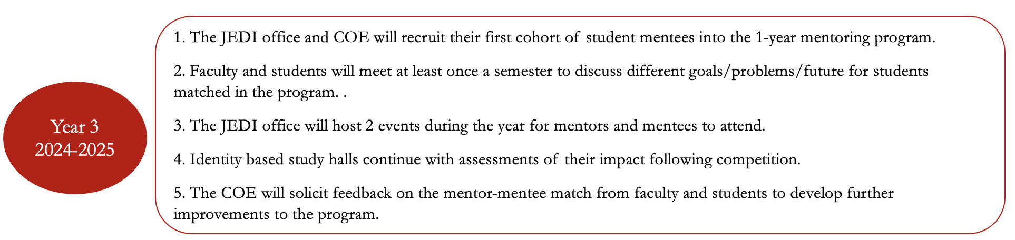

Target Area: Support Students of HM Identities in their Engineering Studies

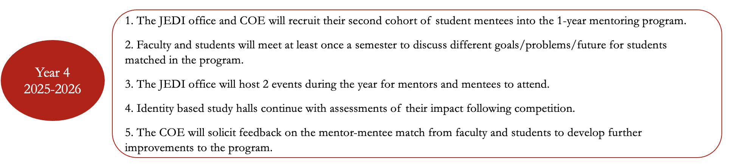

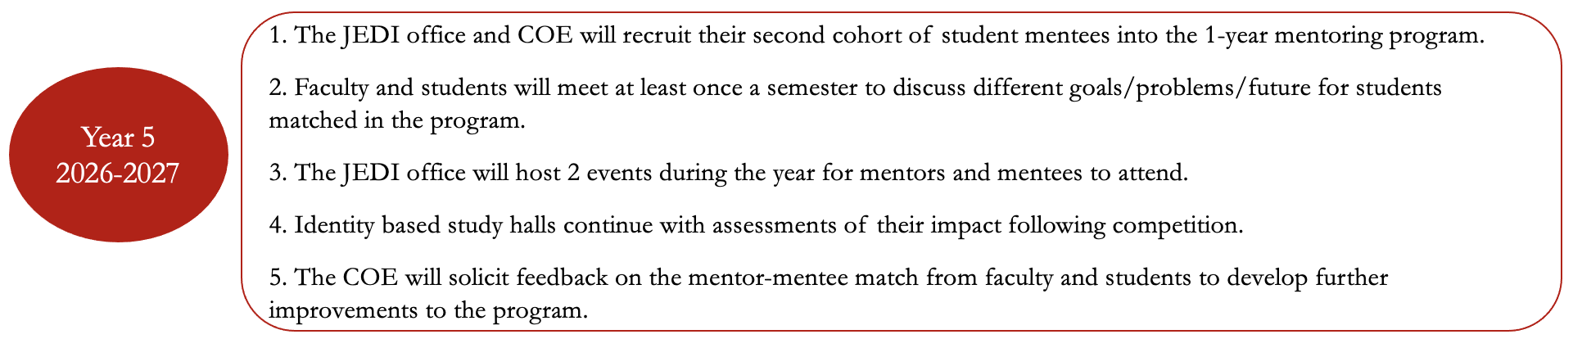

Target Area: Provide Educational Training to Students in the Values of JEDI

There is a need to provide engineering students with education and training in the values and principles of JEDI. Thus, the COE will work with the larger University of Arkansas campus to identify classes students within the COE can take focused on JEDI principles. Additionally, the COE will work to develop a minor within engineering focused on JEDI that students can complete. The COE will assess the impact of taking courses outside the COE and attending the minor program on students’ understanding of JEDI and how they can include these principles in their engineering projects and studies.

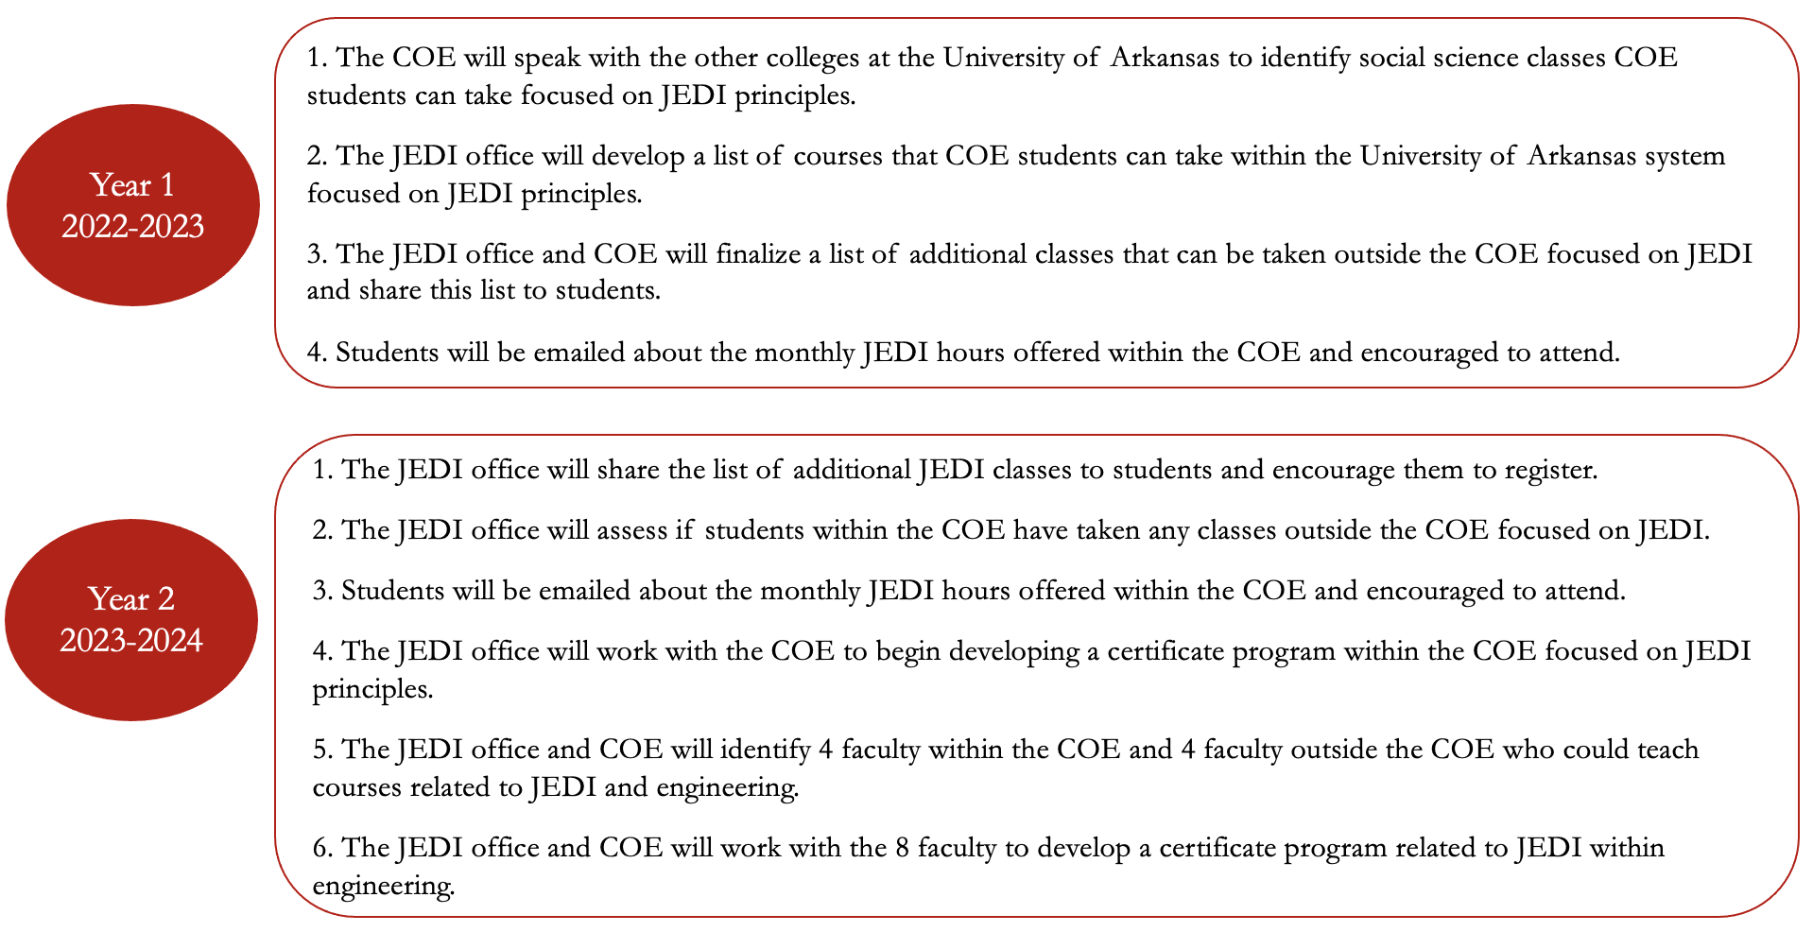
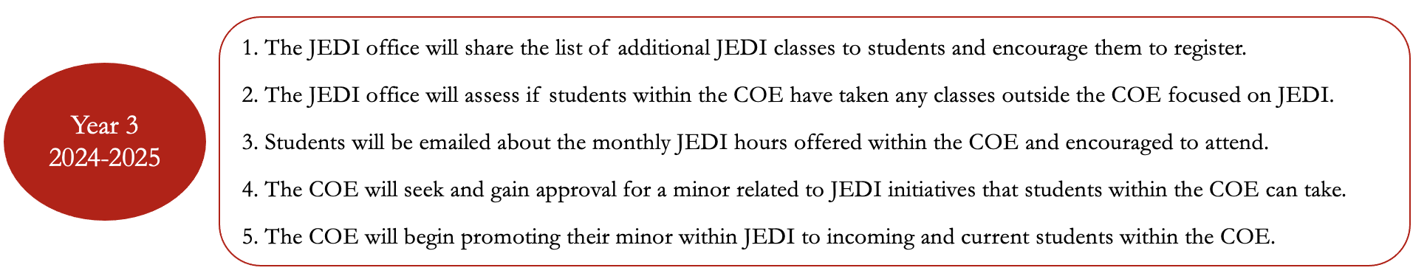
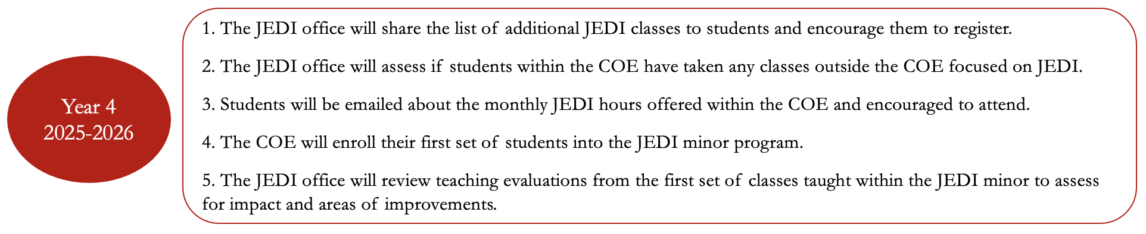

Target Area: Provide Educational Training to Students in the Values of JEDI

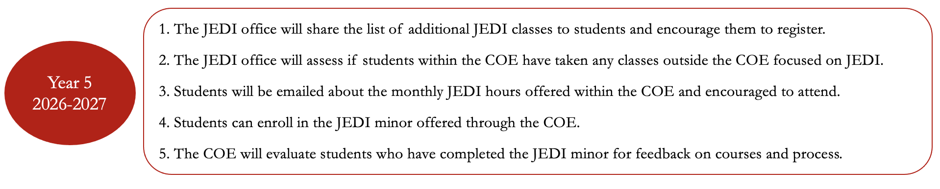

Goal: To support and encourage research scholarship with implications for JEDI and conduct our internal research evaluation of all JEDI initiatives.

Target Area: Internal and External Awards

Within the COE JEDI plan, we also intend to encourage JEDI principles within research activities. To do so, the COE is developing several internal grant proposals that faculty can apply for and would encourage research focused on JEDI. Additionally, the COE is actively seeking out external proposals focused on JEDI that faculty can apply too.

External Awards
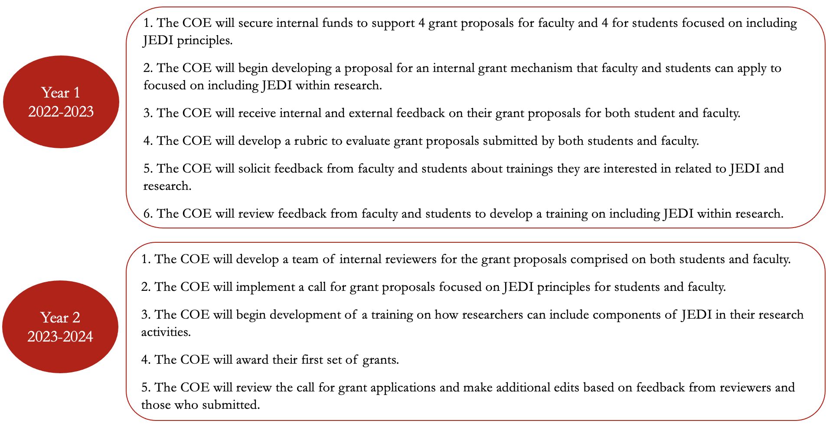
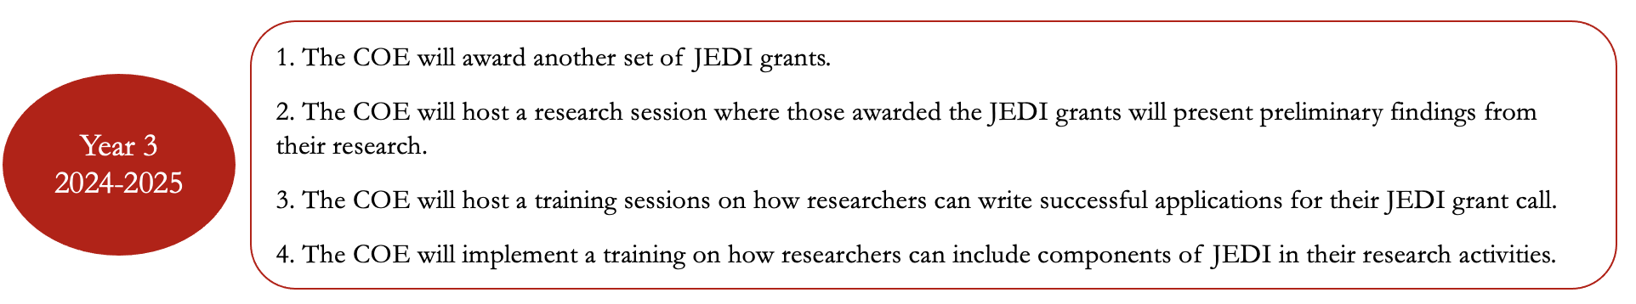
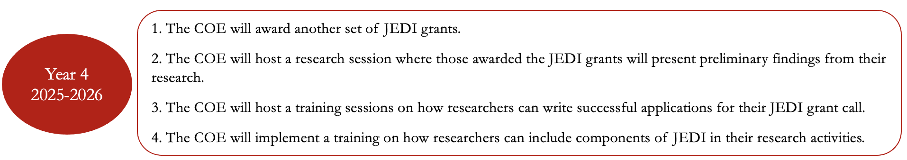

External Awards

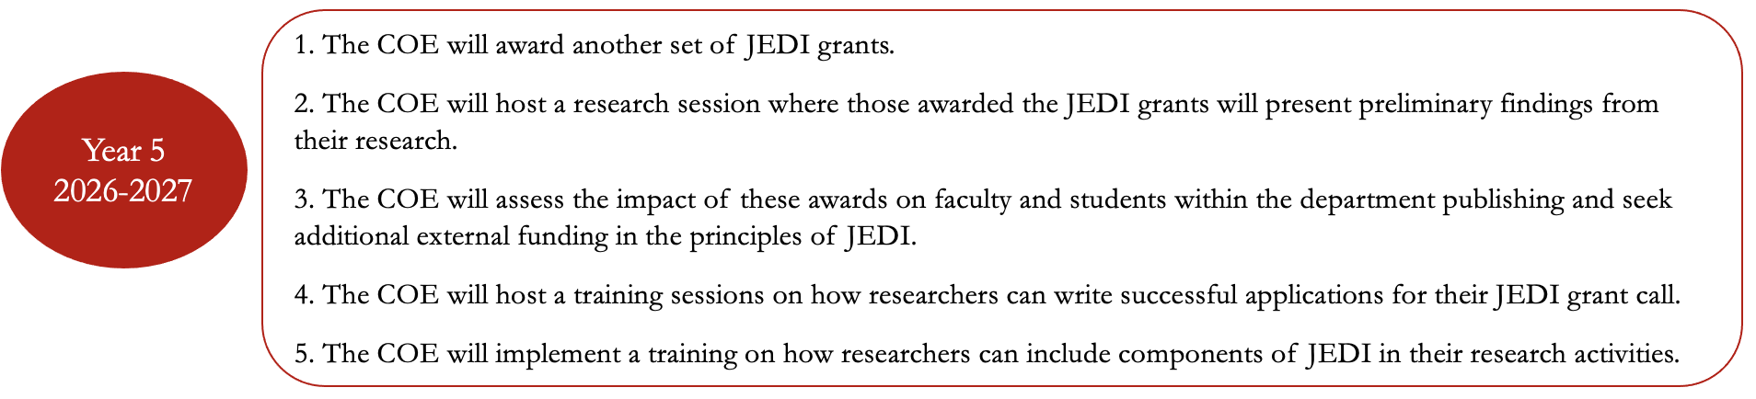

Internal Awards
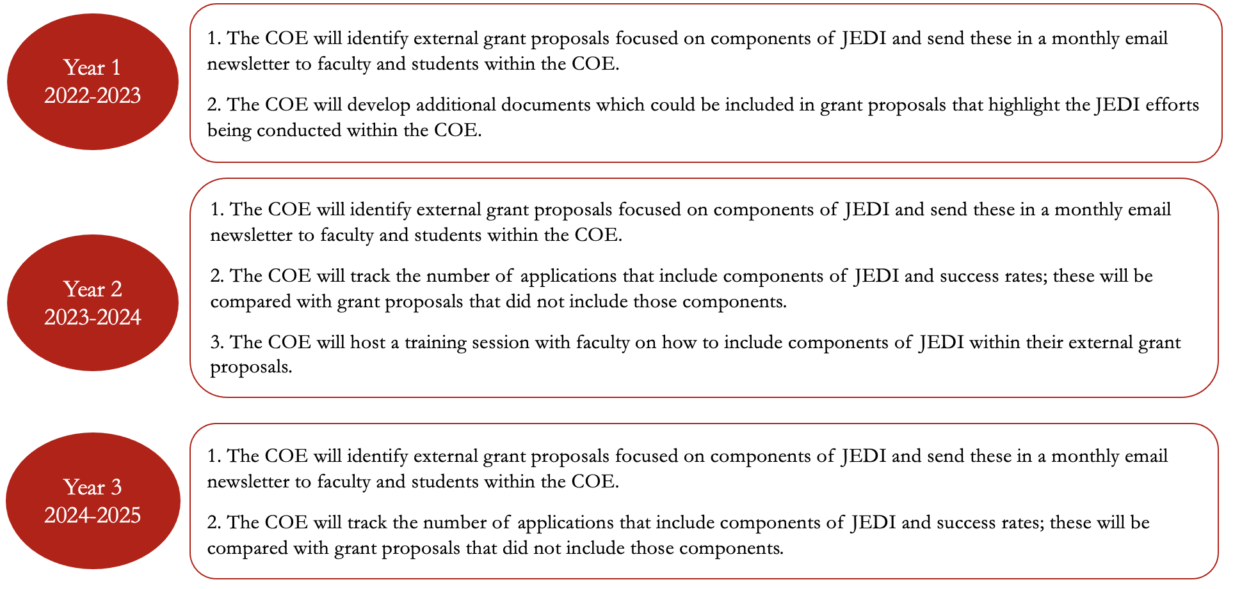
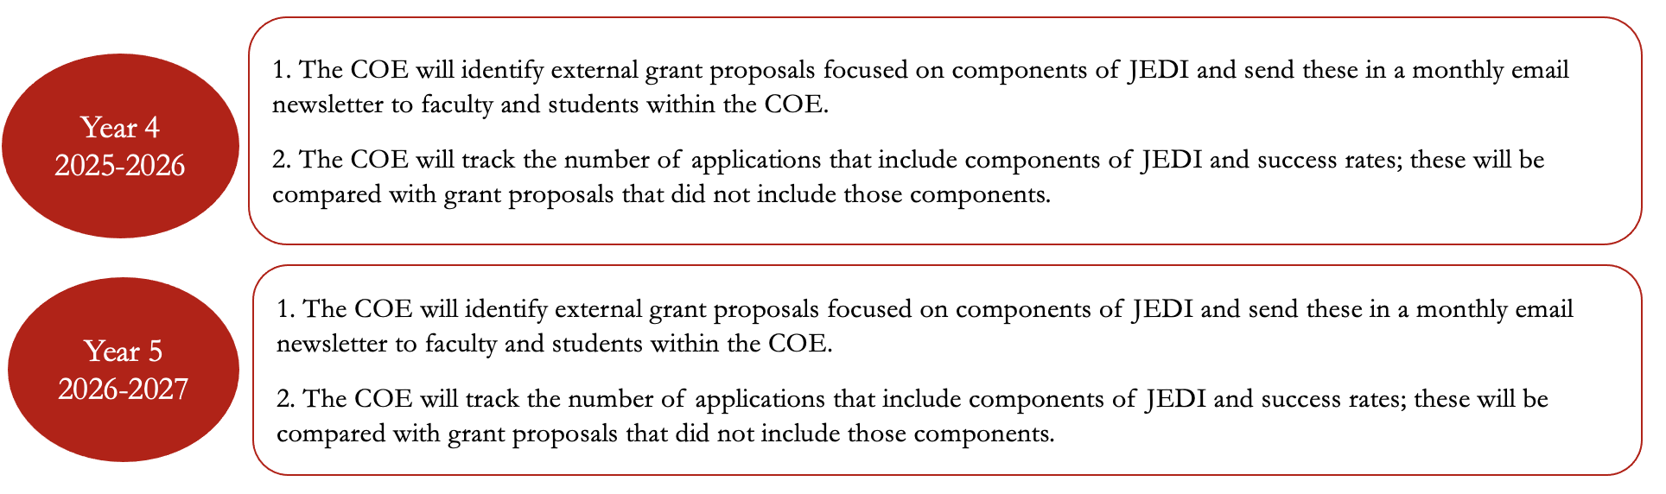

Assistant Director of Justice, Equity, Diversity, and Inclusion (JEDI)
Current Director: Patrice N. Storey

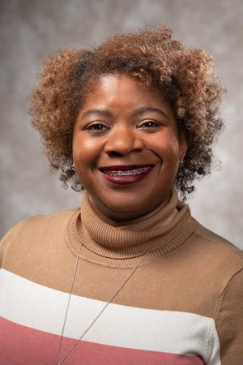
Background: Storey brings to the College of Engineering an extensive university background. Most recently, she served eight years in the Center of Excellence for Poultry Science, where she successfully implemented several 3+1 transfer degree programs. She has served as the DEI liaison for poultry science, served on the Bumpers College DEI committee and as a co-adviser for the Minorities in Agricultural, Natural Resources and Related Sciences. Before her move to the U of A, she worked at the University of Arkansas at Little Rock and the University of Arkansas at Pine Bluff in similar capacity.

Storey is a higher education Ph.D. student in the College of Education and Health Professions. She holds a Master of Science in higher education from Purdue University Global and a Bachelor of Arts in English from University of Arkansas at Pine Bluff.
A native of Pine Bluff, she is married to Marcus N. Storey. She is the mother of two. Collin is a freshman at the University of Arkansas majoring in mechanical engineering and Carrington, a sophomore at Fayetteville High School. In addition, she is the bonus mom to Taya and Blair. She is a member of the Historic St. James Missionary Baptist Church, where she sings in the choir, serves in the women's ministry and the social media team. She is a member of the Lambda Phi Sigma Chapter, Sigma Gamma Rho Sorority Inc.

Job Description: The Assistant Director is responsible for developing, implementing, and advancing JEDI programs for engineering faculty, staff and students

- Manage justice, equity, diversity, inclusion efforts for the college
- Develop and implement program for faculty, staff and students
- Manage communications efforts for the Office of JEDI
- Enhance campus collaborative for the efforts for the college
- Provide educational training sessions for faculty, staff and students which includes but not limited to conscious and unconscious bias training, microaggressions to microaffirmations, and inclusive classroom practices

Current JEDI Programs Offered within the COE

Self-Love Tuesday: The College of Engineering’s Office of Justice, Equity, Diversity, and Inclusion (JEDI) implements a monthly Self-Love Tuesday as a way to promote humility and inclusiveness. Self-Love Tuesday promotes allyship, community belonging, self-esteem, unity, social connectedness, and overall respect for one another.

Monthly JEDI Hour: These are various trainings hosted within the COE or larger campus where an expert in in the areas of JEDI speaks with faculty and students about how they can increase their inclusion and equity practices for different groups. Recently, we hosted a JEDI educational hour on systematic barriers to transgender young adults pursuing an engineering education

JEDI Quarterly Book Series: This Office of JEDI within the COE host a book series reading with staff, faculty, and students related to principles of JEDI. A book is selected at the start of the semester and a small group of individuals meet each week after reading 2 chapters to discuss the principles of the book with the group. A book recently covered in the series was Better Allies: Everyday Action to Create Inclusive, Engaging Workplaces (2nd Edition).

JEDI Educational Training for Faculty & Staff: Faculty within the College of Engineering are given access to trainings on inclusive pedagogy in the classroom, lessons on decolonizing their syllabus, and conscious and unconscious biases trainings. We are also developing a set of courses directly related to engineering and how faculty can expand their research programs to include principles of JEDI.

Monthly Programming for Heritage Months: Each month the JEDI office celebrates and creates different programming related to heritage months. In prior months, the JEDI office has brought speakers in, hosted events, and created social media campaigns related to different heritage months.

JEDI Lunch Series for Graduate Students: The JEDI office host semester lunches with faculty from HM backgrounds to provide them with additional resources related to Engineering, networking opportunities, and further chances to build and foster community. Within these lunch series, speakers are invited in to discuss seeking jobs, applying to postdoctoral positions, how to write statements for jobs, or give a job talk.

JEDI Collaborations with COE RSOs: Both undergraduate and graduate students enrolled in the COE have access to several identity based Registered Student Organizations (RSO) within our college. For instance, we have oSTEM, the Out in Science, Technology Engineering, & Mathematics group which is an engineering RSO devoted to supporting Bisexual, Lesbian, Gay, Queer, and Transgender young adults within engineering. In addition, we have the National Society of Black Engineers (NSBE), the Society of Women Engineer (SWE), Society of Hispanic Professional Engineers (SHPE) and the American Indian Science and Engineering Society (AISES). The JEDI office works with these groups to host joint events related to JEDI initiatives.

The Engineering Career Awareness Program (ECAP) was launched in 2007 to increase the participation of women and other under-represented groups through an individualized participant retention plan that includes a summer bridge program, supplemental need-based scholarships, and targeted co-op/internship opportunities. This nationally praised program has shown that ECAP students are more successful than the engineering freshman class, with statistically significant differences in both retention and grade point average. UARK also participates in the NSF Louis Stokes Arkansas Alliance for Minority Participation working to increase the pool of baccalaureate, masters, and doctoral degree graduates in STEM disciplines in Arkansas' workforce.

UARK hosts two summer programs for rising eighth and ninth grade girls with the goal of increasing the number of women identified, particularly Latina girls, enrolling in high school pre-engineering programs.
Soaring High in Engineering (SHE) is a camp developed specifically for anyone who identifies as a young woman. During this full day camp, attendees will participate in engaging, hands-on activities designed with a real-world theme to expose them to everything a girl can do as an engineer. All women identifying students entering the 6th through 9th grades during the 2022-2023 school year (current 5th through 8th graders) are eligible to apply.

Soaring High in Engineering (SHE) is a camp developed specifically for anyone who identifies as a young woman. During this full day camp, attendees will participate in engaging, hands-on activities designed with a real-world theme to expose them to everything a girl can do as an engineer. All women identifying students entering the 6th through 9th grades during the 2022-2023 school year (current 5th through 8th graders) are eligible to apply.

GirlTREC camp thanks to funding granted to the Maritime Transportation Research & Education Center (MarTREC) by the US Department of Transportation. This camp is developed for girls* who are currently in 5th and 6th grades (entering 6th and 7th in Fall 2022) and will focus on engaging, hands-on activities related transportation engineering from roads to railroads to waterways.

Louis Stokes Alliance for Minority Participation (LSAMP). Arkansas chapter or LSAMP aims to increase the number of under-represented minority students in Science, Technology, Engineering and Mathematics (STEM) areas. This enrichment program is funded by the National Science Foundation and is a collaborative alliance of nine Arkansas institutions that have a goal of increasing the pool of baccalaureate, masters, and doctoral degree graduates in STEM disciplines in Arkansas' workforce.

